User Interface Requirement Specification

The Core
Wireless Speaker System

change history
Date | Person | Version | Comments
2015-01-30 | Frederique Saindon | 0.3 | Revision 3

Table of Contents
change history 1
1 Introduction 3
1.1 Purpose 3
1.2 Scope 3
2.1 KEYS 4
2.2 POWER 5
2.3 led indicators 6
2.4 SPEAKERPHONE 6
2.5 BATTERY CHARGING STATUS DISPLAY 7
2.6 NFC OPERATION 8
2.7 GESTURE CONTROL 9
2.8 VOLUME CONTROL AND MUTING 9
2.9 BLUETOOTH OPERATION & PAIRING 10
2.10 SEQUENCE OF SOURCES 10
2.11 FACTORY TEST MODE 11
2.12 FLASH PLAYBACK MODE 11
2.13 SOUND ANNUNCIATIONS 11
2.14 MULTI-ROOM 12

Introduction

Purpose
This document defines the user interface requirement of the Core Wireless Speaker System. It is to guide the development team to implementing the user interface software.

Scope
This documents covers the user scenarios, UI control flows and the display contents of the aforementioned product.

The graphic in this document is illustrative, the formal graphic comes from Mass Fidelity.

USER INTERACTIONS

KEYS
The unit has 4 tactile keys on the TOP of the unit that have the following functions:

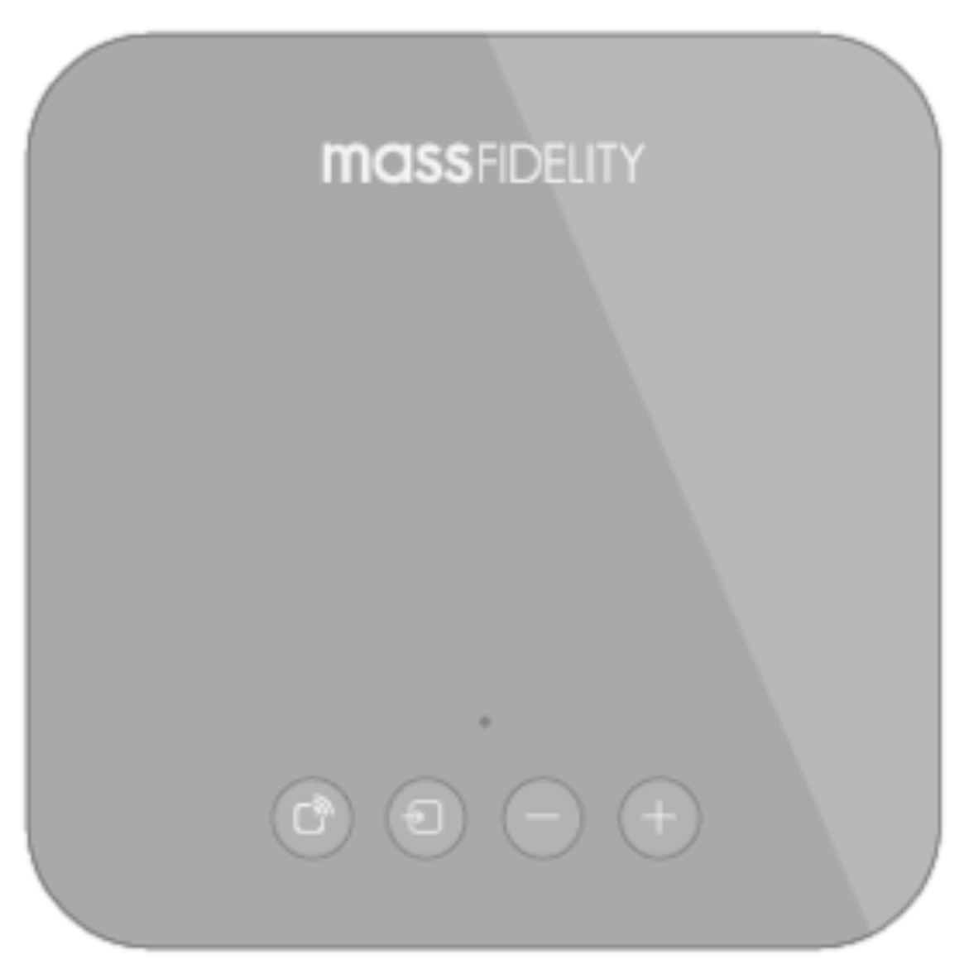
4 tactile keys on top of the unit

Key Function
Key symbol | Key name | Function
 | MULTIROOM | Transmits the currently playing audio on the local unit to the rest of the wireless connected devices.
 | SOURCE | Switches between the 4 input sources as follows:  - Bluetooth  - Multiroom  - Line-in  - Optical > then back to Bluetooth  Also functions as pick-up and hang-up during calls (speakerphone mode)  Also functions as Bluetooth 'force disconnect' in Bluetooth mode only.
 | VOL+ | Increments one volume step.  Long press will continue to increment the  volume for as long as the key is pressed or until maximum volume is reached.
 | VOL- | Decrements one volume step.  Long press will continue to decrement the volume for as long as the key is pressed or until zero volume is reached.

led indicators
1x RGB (red/green/blue) LED on top of the unit delivers the following mode indications:

Top LED Indicator

LED Indication | Condition
Red | Standby (when on DC power).
Breathing Red | Battery within 10% of capacity, DC not connected
Blue | Bluetooth
Purple | Multi-room input
Green | Speakerphone active
White | Line-in mode
Orange | Optical input mode

POWER
There is also a POWER key on the rear of the unit.

Back LED Indicator

Power key

When the unit is connected to the DC supply, pressing the power key will put the
unit into standby, the battery will continue to be charged, the top LED will indicate red and back LED will indicate charging status.

Should the DC power be disconnected during standby, after a short delay the unit will enter full OFF mode to conserve battery power.

During standby mode, pressing any of the keys will wake the unit. The unit can
also be woken by NFC operations or by the remote control (wired and IR).

If the power key is pressed when the unit is on battery power, the unit will completely switch off. If the unit is switched off on battery power then the power key needs to be pressed and held for 3 seconds to switch the unit back on.

Condition | Action | Response | Top LED Colour
Unit powered off,  DC not connected (ie Battery mode) | 3 sec long press | Boot unit | Color of the last source being used.
Unit in standby | Short press on the power key (or ANY of the other keys) | Boot the unit | From Red to last source being used
Unit switched on, in battery mode (ie DC not connected) | Short  Press | Full OFF mode | N/A
Unit switched on, DC connected | Short  Press | Standby mode | From last source being used to Red

POWER SAVING
If the unit has no input audio signals (in the currently selected mode) for a period of time then the unit will automatically shutdown to save power/battery.

Condition | Duration (time without audio signal) | Response
DC connected | 30 minutes* | Standby
Battery power | 10 minutes | Power OFF

*Auto standby can be disabled by pressing the power key for 10 sec.
LED will flash red to show con

SPEAKERPHONE
When in Bluetooth mode, should the connected handset receive a call then the
music will be gently faded out, the LED will change to green and the source key will
change to a pick-up/hang-up function. If the source key is pressed when a call is ringing, the call will be answered, if this key is pressed again during the call then the call will be disconnected.

Condition | Response | LED
Receiving a phone call, in Bluetooth Mode | Music is gently faded out | LED changes to Green
Source Key is pressed when a call is ringing | Call is answered | LED is Green
Source Key is pressed again during the call | Call is disconnected | LED color returns to previous state before call (Bluetooth)

During speakerphone operation all battery status display is paused.

SPEAKERPHONE PRESETS

State | Key combination | LED
Disable  (Always-off) | Simultaneous 5 sec press of Power & Source key | Top LED flashes Red to confirm speakerphone functionality is disabled.
Enable  (Always-on) | Simultaneous 5 sec press of Power + Source key | Top LED flashes Green to confirm speakerphone functionality is enabled.

BATTERY CHARGING STATUS DISPLAY

DC NOT CONNECTED

When the battery is being discharged (DC not connected), the unit will display that
the battery is within the last 10% of its capacity, the top LEDs will pulsate red, independent of the source.

Top LED Indicator

LED Indication (on top of the unit) | Condition
Quick Breathing Red | Battery within 10% of capacity, DC not connected

UNIT ON CHARGE
When the unit is on charge, the battery status will be displayed via the rear LED. Low battery information (breathing red) will not be displayed on the top LED when unit is on charge.

Back LED Indicator

LED Indication (next to power connector) | Condition
Yellow | Battery charging
Green | Battery charged (>90%)

NFC OPERATION

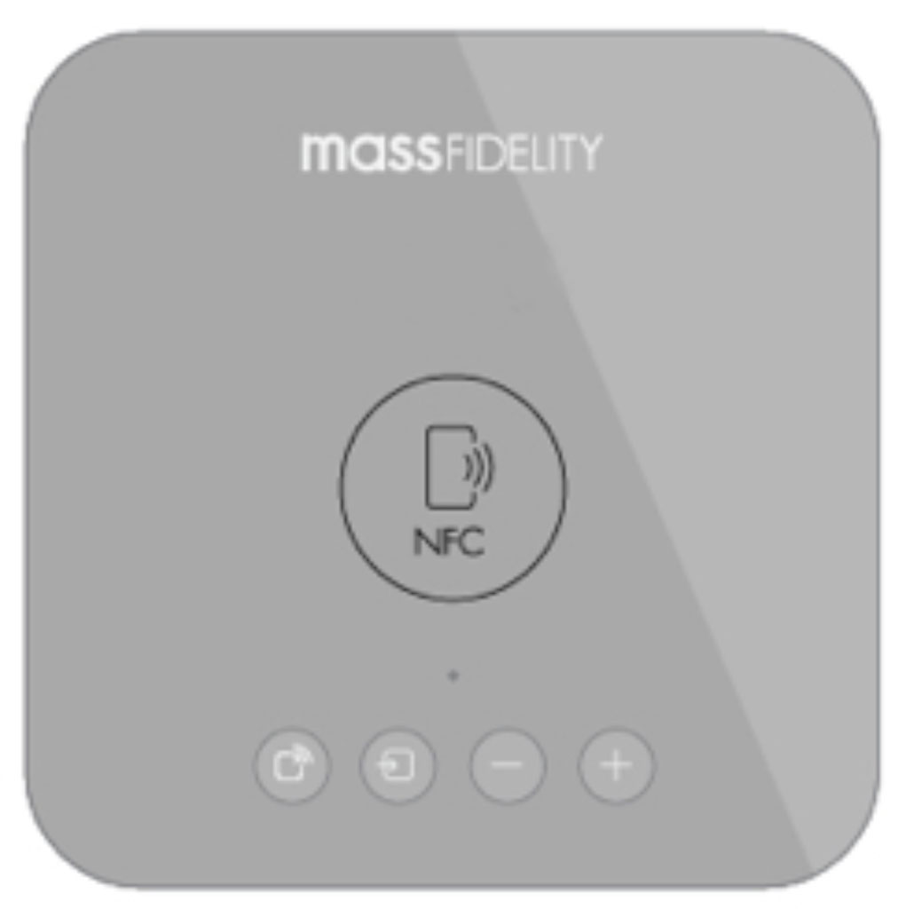
NFC antenna

If an NFC enabled handset is brought near to the NFC antenna then the unit will
respond in the following ways:

Unit State | Response
Power ON | Switch to BT mode and pair to that device. Allows for “hijacking” of current connection
Standby | Switch ON, BT mode enabled, pair to that device
Power OFF | Switch ON, BT mode enabled, pair to that device

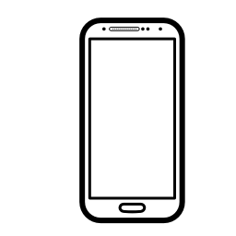
In addition, some NFC enabled handsets will automatically switch on the Bluetooth radio in the handset if not already switched on.

GESTURE CONTROL
Gesture Control removed from SPECS

VOLUME CONTROL AND MUTING
Volume control is in 32 steps, step 0 represents a muted condition and step 31 is
0dB. When changing between input sources, entering or leaving mute more or
entering or leaving standby mode the system implements a soft muting scheme,
the time taken to mute is dependent upon the current volume level. After the soft
mute finishes the volume level will be returned to the original level.

In standby mode all settings are remembered by the unit. If the unit is put in to
standby mode at any volume above 75%* output, when the unit is switched back on,
it will return to 75%*.

Default minimum volume step is 9

If the unit is shutdown, the default settings for the new power-on state are dependent, as follows:

Power Condition | Volume | Source
DC connected | Whenever unit is turned back on, last volume used is remembered assuming it is not louder than step 25. | Last source
Battery power | Whenever unit is turned back on, last volume used is remembered assuming it is not louder than step 25. | Last source

MUTING

Condition | Response | LED
Pressing mute button on Remote control | Mute | Slow breathing source color
Pushing the volume to step 0 | Mute | Slow breathing source color

BLUETOOTH OPERATION & PAIRING
The Bluetooth uses open pairing, when the unit is disconnected from any handset
of device, the blue LED indication will flash to indicate that the unit is
disconnected and that other handsets can be paired or connected.

The Bluetooth radio will be disabled when Bluetooth mode is not selected. When
the Bluetooth function is first enabled, it will attempt to auto-connect to the last
connected device. If last connected device is not available it will then wait in the disconnected state for either a previously paired device to be manually connected or for a new device to pair to it.

Condition | Response
Unit disconnected from any handset | Blue LED flashes, indicating unit is disconnected and that other handsets can be paired or connected.
Bluetooth mode is not selected | Bluetooth Radio will be disabled
Bluetooth function is first enabled | Will attempt to auto-connect to the last connected device
If last connected device is not available | Wait in the disconnected state for either a previously paired device to be manually connected or for a new device to pair to it.
Source key is pressed for 5 sec | Forced disconnection of pairing

SEQUENCE OF SOURCES
The default (from full OFF) input source is the last source that was used. From standby, the last source will be remembered.

First power ON (unboxing the unit),
Default input source = Bluetooth

From full OFF,
Default input source = Last source being used

From Standby,
Default input source = last powered mode before standby
Pressing the source key further = default sequence

In power-up session,
Pressing the source key further = default sequence

Default sequence,
- Bluetooth
- Multiroom
- Line input
- Optical -> then back to Bluetooth

FACTORY TEST MODE
NEC command to be programmed into the remote control to allow for factory testing of the features of the Core.

FLASH PLAYBACK MODE
Flash Playback mode to be removed from SPECS

SOUND ANNUNCIATIONS
Custom sound for:
- Power up,
- Power down,
- Pairing Mode,
- Paired,
- Transmitting,
- Positive Confirmation, (enable sound)
- Negative Confirmation, (disable sound)

The length and content of the audio prompts is to be defined.

MULTI-ROOM
The Core features a self-contained network function that requires no external infrastructure or internet access. It uses a 5.2/5.8 GHz frequency hopping network to achieve uncompressed digital audio distribution above CD quality.

The network uses a star topology in which only one Core speaker can be the transmitter at any one time, all of the others must either be receivers or configured as independent speakers. There can be up to 8 Core speakers connected on the same network at the same time.

At any time, any of the receiver units can be turned into the transmitter, simply by pressing the multi-room key. For the other units to receive the signal, the multi-room mode must be selected through their source key.

Condition | Action | Top LED Colour
To Transmit to other Core units | Short press on Multi-room key | Purple then back to source colour
To Receive from Transmitting unit | Select Multi-room from the Source key | Flashes purple until connection is made
To enable Subwoofer on the network | Simultaneous press and hold on Power & volume keys “+” for 5 seconds | Will flash once Green
To disable Subwoofer off the network | Simultaneous press on Power & volume “-” | Will flash once Red

